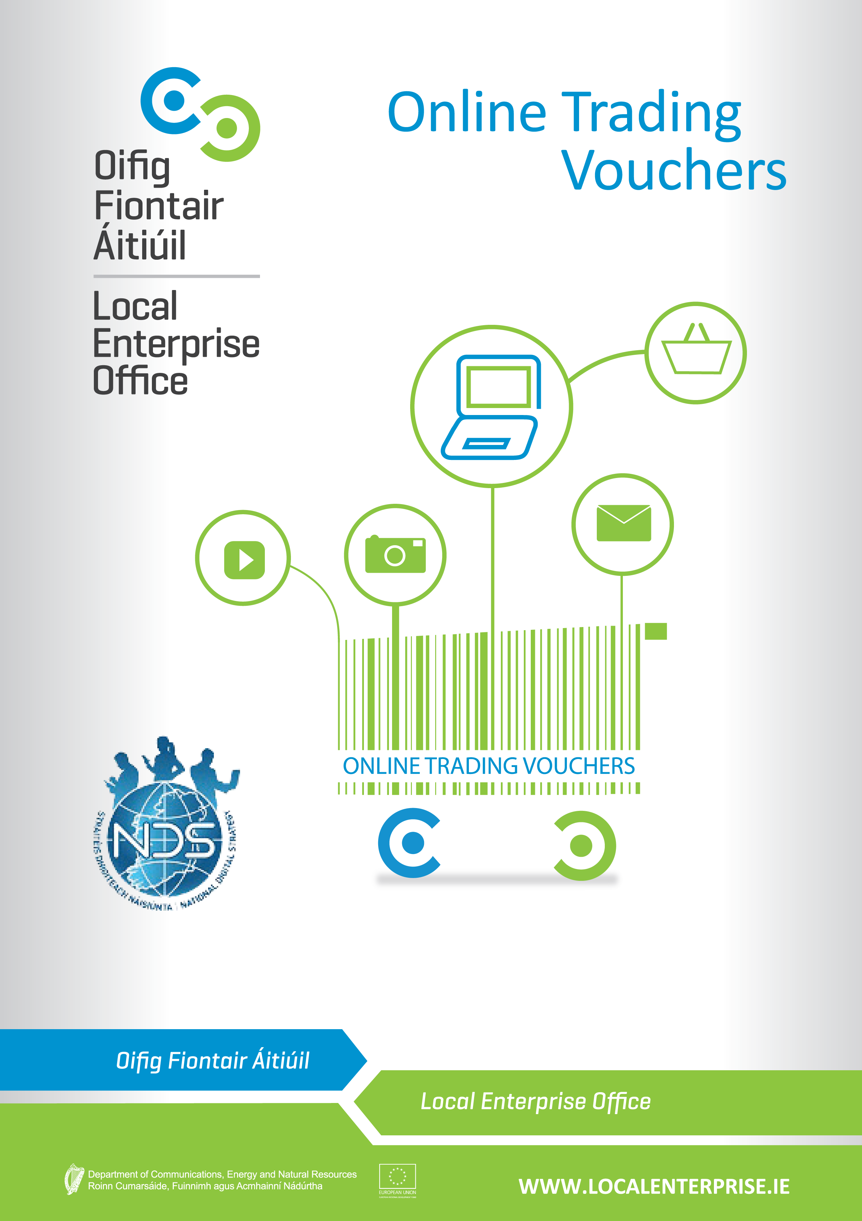
ONLINE TRADING VOUCHERS
With the trend ever increasing towards online spending it is estimated that only 23% of small Irish businesses are engaged in any meaningful way in eCommerce sales. For businesses employing less than ten people this percentage could be even lower. It is now believed that of online purchases made in Ireland that 70% of these are done in overseas markets.
There is now an urgency to ensure that businesses recognise that this is happening and that they are encouraged and supported to correctly respond to this digital reality.
In order to support this goal, the National Digital Strategy aims to get a further 2,000 businesses trading online by the end of 2015. To this end, the Department of Communications, Energy & Natural Resources (DCENR) has launched an Online Trading Voucher Programme and has teamed up with the Local Enterprise Offices to deliver this to Irish business. Following a successful first pilot phase in Dublin City, the scheme will be scaled up and businesses from the following Counties are being invited to apply:
CORK/DUBLIN/KERRY/LOUTH/SLIGO/WATERFORD
Information seminars will be available in each of the pilot areas over the next few weeks and it will be a condition of applying for the vouchers that applicants attend one of these seminars. At each seminar attendees will be informed of the purpose of the scheme and how best to use and get value from the application of the voucher.
Businesses are now invited to book a place on the seminars which can be done here (include link to online booking). The application process for the Vouchers will be a competitive process.
Eligibility Criteria
- Vouchers will be available to a maximum value of €2,500 or 50% of eligible expenditure (Inclusive of VAT), whichever is the lesser;
- Voucher approval must be gained prior to incurring any expense;
- Own labour is not an eligible expense;
- Third party costs only will be considered;
- All third party/supplier invoices must contain proper business details (e.g. Tax and Business Registration details).
The vouchers are targeted at businesses with the following profile:
- Limited Online Trading presence;
- Less than 10 employees;
- Turnover less than €2m;
- Applicant business must be registered and trading for at least 12 months;
- Business must be located in the area covered by this phase of the scheme i.e. within the remit of the participating LEOs.
Ineligible Projects
- Companies with charitable status, commercial semi-state companies, “not for profit” organisations, trade associations and company representation bodies such as Chambersof Commerce are not eligible to participate in the scheme;
- Professional services specialising in IT type services who are already capable of trading online using existing in-house systems;
- Conferences and Seminars;
- Projects which are contrary to public policy;
- Duplication of support for projects which would be eligible for assistance from otherState Agencies of EU funded Operational Programmes;
- Projects with employees in excess of 10 people;
- Projects deemed to be capable of proceeding in any event without scheme assistance i.e. deadweight;
- Projects essentially comprising importation and distribution.
What the vouchers can be used for
- IT consultation;
- Development or upgrade of an e-commerce website;
- Implementing Online payments or booking systems;
- Purchase of Internet related software;
- Purchase of online advertising (this purchase cannot make up any more than 30% of approved Voucher costs and can only be drawn down in one payment phase);
- Developing an app (or multiplatform webpages);
- Implementing a digital marketing strategy i.e. Social media marketing;
- Consultation with ICT experts for early stage adopters of online strategy;
- Training/skills development specifically to establish and manage an on-line trading activity.
What the vouchers cannot be used for
- Development of brochure websites;
- Purchase of non-internet related software;
- Anything other than online trading related activity.

EVALUATION PROCESS
- An evaluation committee will assess the applications and make recommendations for approval;
- A competitive process will be put in place to assist with selection process. Selection of successful applicant will be based on the following criteria:
  - Eligibility for scheme
  - Value added potential
  - Export potential
  - Job creation potential
  - Financial Sustainability
- Record decisions and report to the Local Enterprise Office approvals committee;

VOUCHER ADMINISTRATION
- Letter of offer with Voucher to be sent out to successful applicant;
- Letter of offer signed, accepted and returned;
- Client has three months to complete the work as per their application;

Voucher application and drawdown process:
Application
- Read the terms & conditions;
- Submit copy of completed and signed application form in hard copy to your local LEO;
- Soft copy of completed application to be supplied by email to your local LEO;
Evaluation
- Evaluation of applications will be conducted by each LEO who will make recommendations for approval;
- Application is approved by Local Enterprise Office Committee.

Drawdown
- Applicant and supplier(s) sign declaration on the voucher and submit to Local Enterprise Office (LEO);
- Applicant and Supplier(s) submit copy of an up to date tax clearance certificate ;
- Applicant must include the original invoice from the supplier(s), along with supplier(s) CRO and Tax Registration details when submitting claim for payment(Only suppliers with these basic criteria in place are eligible);
- Proof of payment to supplier(s) submitted by applicant to LEO;
- All work must be completed and paid for prior to claim.

Post-Voucher reporting

By accepting a Trading On-line Voucher, businesses agree to provide information on the impact on their business of trading on-line;
- Reporting will include: Jobs (new or reallocated) , Exports and/or domestic market expansion, Increase Revenue, Reduced Costs, Expected follow on investment;
Suppliers will be required to report on the impact of their products and services supplied to the applicant business.
- Reporting will include how their product or service enabled trading on-line, improved business performance, reduced cost, opened markets etc.
Acknowledgements
The trading on-line voucher scheme is an initiative of the National Digital Strategy, developed and funded by the Department of Communication, Energy and Natural Resources on behalf of Government. It is being administered by the Local Enterprise Offices.

PLEASE NOTE: The Local Enterprise Office is not responsible for any disputes between the applicant and 3rd party suppliers. Therefore we recommend that you adhere to best business practice and get three quotes as well as carry out due diligence before selecting a supplier. Disclaimer – For the avoidance of doubt it is understood and accepted that it is the applicant companies who are selecting and entering into a contract with third parties. The State and its agents (including Local Enterprise Office(s), Enterprise Ireland or any Government Department) does not accept any liability whatsoever in respect of any deficit in or consequences arising from products or services procured by or provided to companies under this scheme. In submitting your application under this scheme you are confirming that you understand and accept this disclaimer.
Further Terms
Applications for assistance for expenditure incurred prior to grant approval are ineligible. The Local Enterprise Office reserves the right to refuse any application and the right to terminate this grant scheme at any time without notice. The approval of applications and the payment of all monies are dependent on the availability of resources under this scheme from the Department of Communication, Energy and Natural Resources. Applicants are advised to check availability of resources with Local Enterprise Office prior to applying. All applicants approved must draw down in full within four months of the date of offer, or in exceptional circumstances such time as may be agreed between LEO and company. Failure to draw down all or any portion may result in automatic decommittal without notice, i.e. loss of voucher. The Local Enterprise Office may liaise/consult other agencies/local development programmes in relation to this proposal while respecting project confidentiality. Any false or misleading statement or the withholding of essential information from Local Enterprise Office (as determined by Local this scheme.
Declaration
I hereby declare that the information and details provided on behalf of the applicant business are accurate and true to the best of my knowledge and belief. I make this application as a duly authorised officer for and on behalf of applicant business for grant assistance on the basis of the information and details given. I have not sought and will not seek grant aid from any state agency or other sources in respect of this expenditure. I have read and fully accept the terms & conditions attaching to the ‘Online Trading Voucher’.
Sign by Business Name | Date

If your application is successful, an Online Trading Voucher will be sent to you for you to forward to your preferred supplier.
- Payment will be made directly to you upon satisfactory receipt of the following:
- Copy of your Company Registration Office (CRO)/Revenue registration
- Up to date Tax Clearance Certificate
- Original Invoice(s) for work undertaken
- Declaration of project completion by supplier(s)
- Bank statement(s) showing proof of payment from the client company along with evidence of
Supplier(s) Company Registration Office (CRO) details
- Payments will only be made with relation to approved expenses which form part of this application form
- All successful applicants agree to report on online trading from participation in the scheme, again in 6 months and at annual intervals up to three years thereafter. Reporting will include: jobs (new or reallocated), increase turnover, exports and/or domestic market expansion, reduced costs, expected follow on investment. This may be conducted by Local Enterprise Offices, Department of Communications, Energy and Natural Resources or approved independent evaluators.
- Applicants agree that they will allow reference be made to them in case study materials, which may be used to promote the voucher scheme more widely.
Online Trading Voucher Application: SIGNATURE FORM

This form will provide you with a project specification that you can use to circulate to suppliers and will also be the basis for nearly all your application for the voucher.
Name:
Company name:
Company address:
Telephone:
Mobile:
Email:
Website address: |  | Tick if not online

Business objective for your Trading Online project (Max 150 words):
What is it that your business expects this project to do that will help your business? Handle sales, generate new leads, handle customer service, etc… (please be as specific as possible)
Description of your Business's Products / Services (150 words max)
Overview of your businesses activities whether related to the project or not

Unique Value Proposition of your Products / Services targeted in this project (Max 150 words):
Look at your online competitors, decide what products/services you will focus on - not all of them need to be traded online. Why did you select what you have?
Your Target Market through this project (Max 150 words)
Who are your customers going to be?
Trading online competitors (list 3 to 5 with their a link to their websites):
When you use a search engine to look for the product /services your company offers, what companies/sites are displayed
Market expansion potential (Max 150 words):
Based on your target market and competitor analysis, how will this project help you grow your revenue? Export potential? Gain back lost market share to existing online traders?

Internal resources brought to the project
External resources brought to the project
Existing Assets the project should leverage off
What additional information can you provide to help suppliers assist you? Social media presence you want to leverage? Design material? Photographs? Brand & marketing material?
Scope of work to be carried out (Max 150 words)
What are the specific deliverables of the project relating back to the business objectives?

The work you are seeking to have done by external service provider(s) will entail (click all that are applicable) | Yes | Unsure
IT Consultation
Project Management
New eCommerce site development (from scratch)
Upgrade of existing eCommerce site
Content Management System – a computer program that allows publishing, editing and modifying contentas well as maintenance from a central interface
Implementing an online payments system
App development
Digital Marketing Strategy and associated online advertising
Training specific to the establishment of trading online
Copy (written or graphic content) for website
Search Engine Optimisation (SEO) services – process of optimizing the visibility of a website or a web page in a search engine’s organic search results.
Analysis of existing site analytics – analyzing web data for purposes of understanding and optimizing web usage

Business type:
CRO Number:
Year business was established
How long has the business been trading?
 |  | Current |  | Projected 12 months |  | Projected 24 months
Turnover
Staff numbers
- Full time
- Part-time
Trading Online Expenditure
 |  | Product / Service |  | Service provider |  | Cost (€ Excluding VAT)
Supplier 1
Supplier 2
Supplier 3
Add additional supplier quotes
Online Voucher request amount
- Expected cost based on quotes (ex VAT) |  | €
Eligible voucher amount requested€2,500.00 Maximum voucher award |  | €

Your Local Enterprise Office:
Application received!
You'll also receive a confirmation email that we've received your application.
VOUCHER PAYMENT CONDITIONS
* | If your application is successful you will receive an Online Trading Voucher to the value of the amount approved. (Maximum Grant/Voucher inclusive of VAT is €2,500)
* | Payment will be made directly to you on completion of the work and subject to the following being provided satisfactorily:
1 | Copy of your Company Registration Office(CRO) or revenue registration
2 | Up to date tax Clearance Certificate
3 | Original Invoice(s) for work undertaken
4 | Declaration of project completion by supplier(s)
5 | Bank statement(s) showing proof of payment from the client company along with evidence of supplier Company Registration Office (CRO) details
* | Payments will only be made with relation to approved expenses which form part of this application form
* | All successful applicants agree to report on online trading upon completion of the scheme, again in 6 months and at annual intervals up to three years thereafter. Reporting will include: jobs (new or reallocated), increase turnover, exports and/or domestic market expansion, reduced costs, expected follow on investment. This may be conducted by approved independent evaluators.
* | Applicants agree that on successful completion of their projects they will allow reference be made to them in case study materials which will be used to promote the voucher scheme more widely.
* | INCLUDE RETURN EMAIL AND OFFICE ADDRESS FOR HARD COPY HERE
PLEASE NOTE:Local Enterprise Office is not responsible for any disputes between the applicant and 3rd party suppliers. Therefore we recommend that you adhere to best business practice and get three quotes as well as carry out due diligence before selecting a supplier.
IMPORTANT: Applications for assistance for expenditure incurred prior to grant approval are ineligible. The Local Enterprise Office reserves the right to refuse any application and the right to terminate this grant scheme at any time without notice. The approval of applications and the payment of all monies are dependent on the availability of resources under this scheme from the Department of Communication, Energy and Natural resource. Applicants are advised to check availability of resources with Local Enterprise Office prior to applying. All applicants approved must draw down in full within four months of the date of offer. Failure to draw down all or any portion may result in automatic decommittal without notice, i.e. loss of voucher. The Local Enterprise Office may liaise/consult other agencies/local development programmes in relation to this proposal while respecting project confidentiality. Any false or misleading statement or the withholding of essential information from Local Enterprise Office (as determined by Local Enterprise Office) will result in cancellation of any grant approved under this scheme
DECLARATION:I/We hereby declare that the above information and details are accurate and true to the best of my knowledge and belief and I make this application for grant assistance on the basis of the information and details given. I/We have not sought and will not seek grant aid from any state agency or other sources in respect of this expenditure. I have read and fully accept the terms and conditions attaching to the ‘Online Trading Voucher’ from Local Enterprise Office.

